CLOUD PLATFORM ENGINEERING
Architecture Governance &
Sign-off Framework

A Stage-Gate Control Model for Design, Security, Integration & Operational Approval prior to Terraform / IaC Development
PREPARED FOR
Platform Engineering & Architecture Review Board
August 2026

Contents

Executive Summary 3
1 System Architecture Sign-off Framework 4
2 Application Component Design Sign-Off 5
3 Database Architecture Sign-Off 6
4 Edge Component Design Sign-Off 7
5 Network Architecture Sign-Off 8
6 Security Architecture Sign-Off 9
7 Observability Design Sign-Off 10
8 Component Integration Sign-Off Template 11
9 End-to-End Logical Flow Sign-Off 12
10 Terraform Readiness Sign-Off — Mandatory Gate 14
Final Signatories 15
Golden Rule for Platform Engineering 15

OVERVIEW

Executive Summary
This is a governance control for Platform Engineering.
A common reason for failed cloud transformations is that Terraform / IaC development starts before Architecture, Integration, Security, Resiliency, and Operational designs are formally approved.

Governance Domains at a Glance
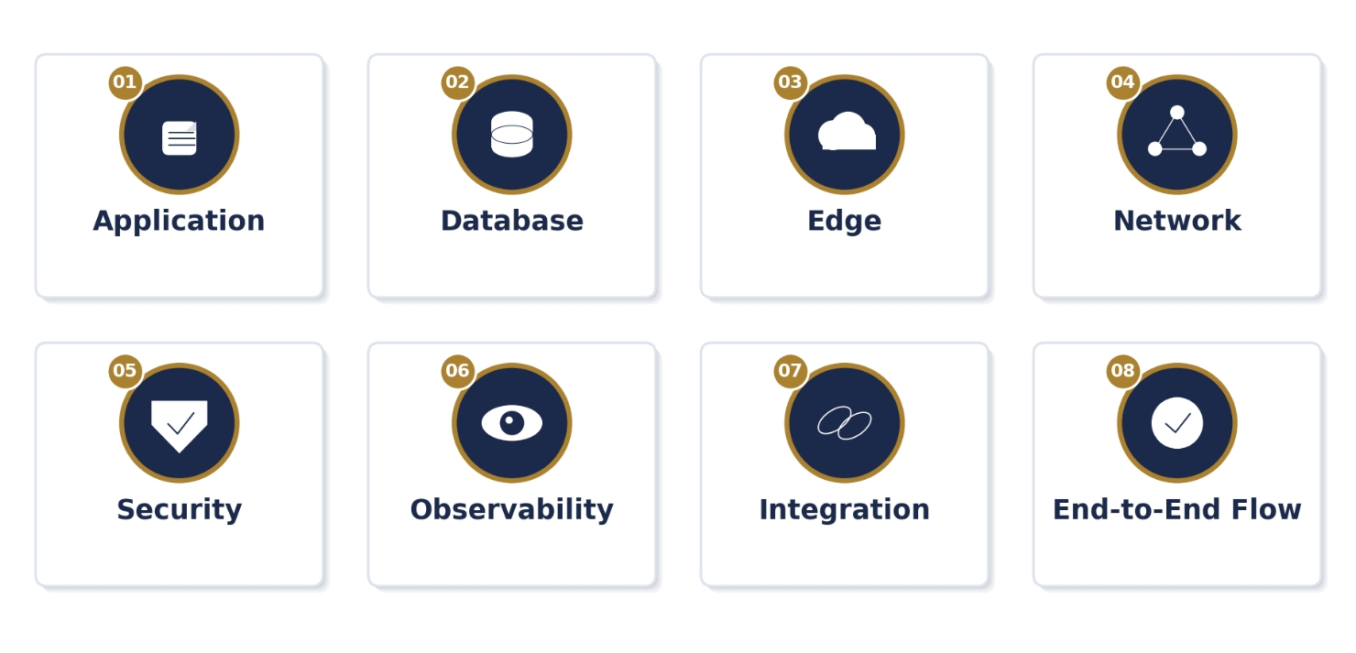
Recommendation — maintain two separate, complementary sign-off templates:
◆ Component Design Sign-off Checklist (App, DB, Network, Edge, Security, Integration, Observability, etc.)
◆ End-to-End Logical Flow and Integration Sign-off Checklist

 1 System Architecture Sign-off Framework

Stage-Gate Flow
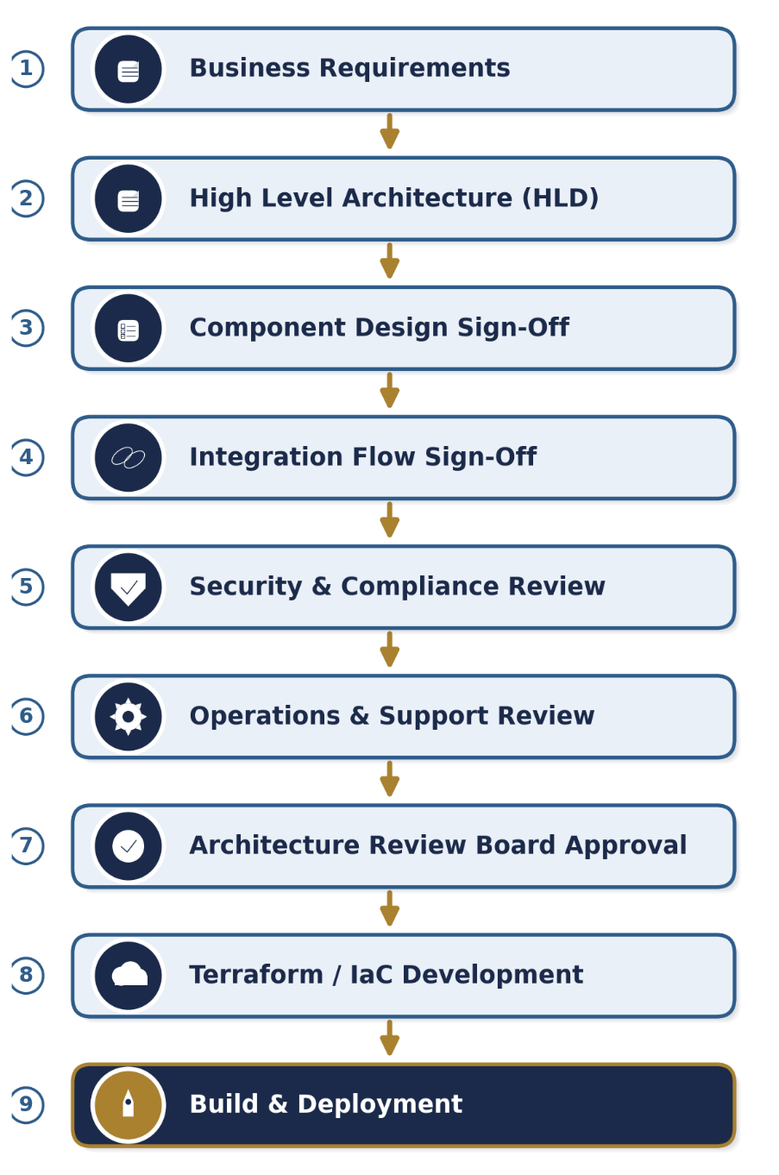

No stage may be skipped. Each gate must be formally signed off before the next stage begins — Terraform / IaC development is explicitly gated behind Architecture Review Board approval.

 2 Application Component Design Sign-Off

Application Architecture Review
Area | Validation Item | Sign-off
Functional Design | Business requirements mapped | ☐
Service Model | Monolith / Microservice documented | ☐
API Design | API specification available | ☐
Scalability | Horizontal scaling defined | ☐
Statelessness | Session handling strategy defined | ☐
Configuration | Externalized configuration | ☐
Secrets | Vault-based secrets management | ☐
Error Handling | Retry and exception strategy | ☐
Dependency Mapping | Upstream / downstream documented | ☐
Logging | Structured Json logging defined | ☐
Metrics | SLI / SLO metrics identified | ☐
DR Strategy | Recovery process documented | ☐
Capacity Planning | TPS sizing validated | ☐
Failure Handling | Circuit breaker strategy | ☐
Deployment Strategy | Blue/Green or Canary defined | ☐
Tech Currency | Supported framework version | ☐
Required Artifacts
◆ HLD
◆ LLD
◆ API Specification
◆ Sequence Diagram
◆ Capacity Model
◆ SLO Definition
◆ Security Architecture

 3 Database Architecture Sign-Off

Database Design Review
Area | Validation Item | Sign-off
Database Type | SQL/NoSQL rationale approved | ☐
Data Model | ER Diagram reviewed | ☐
Normalization | Schema reviewed | ☐
Partitioning | Strategy documented | ☐
Indexing | Performance index validated | ☐
HA Design | Multi-zone architecture | ☐
Backup | Backup policy approved | ☐
Recovery | RTO/RPO validated | ☐
Encryption | At-rest encryption enabled | ☐
In-transit Security | TLS enforced | ☐
Audit Logging | Database audits enabled | ☐
Capacity | Growth forecast available | ☐
Archival | Data lifecycle strategy | ☐
Purging | Regulatory compliance addressed | ☐
Failover | Automated failover validated | ☐
Required Artifacts
◆ ER Diagram
◆ Capacity Plan
◆ Backup Strategy
◆ DR Procedure
◆ Data Retention Policy

 4 Edge Component Design Sign-Off

Load Balancer / API Gateway / WAF
Area | Validation Item | Sign-off
Endpoint Inventory | All endpoints identified | ☐
DNS Design | DNS ownership validated | ☐
SSL/TLS | Certificate lifecycle defined | ☐
Load Balancing | Distribution strategy defined | ☐
WAF | Rules reviewed | ☐
DDoS Protection | Strategy approved | ☐
Rate Limiting | API throttling defined | ☐
Authentication | OAuth / SAML / JWT approved | ☐
Session Persistence | Validated if required | ☐
API Gateway | Routing documented | ☐
Health Checks | Endpoint validation configured | ☐
Logging | Access logs enabled | ☐
Monitoring | Latency metrics defined | ☐
Security Headers | HSTS/CSP implemented | ☐

5 Network Architecture Sign-Off

Connectivity Review
Area | Validation Item | Sign-off
VPC Design | Approved | ☐
CIDR Planning | No overlaps | ☐
Routing | Reviewed | ☐
MPLS Connectivity | Tested | ☐
VPN Gateway | Configured | ☐
ExpressRoute / Interconnect | Approved | ☐
Firewall Rules | Reviewed | ☐
East-West Traffic | Controlled | ☐
North-South Traffic | Documented | ☐
DNS | Architecture approved | ☐
Proxy | Defined | ☐
Segmentation | Security zones approved | ☐

 6 Security Architecture Sign-Off

STRIDE-Based Security Review
Area | Validation Item | Sign-off
Authentication | Enterprise standard | ☐
Authorization | RBAC documented | ☐
Encryption | TLS 1.2+ enforced | ☐
Secrets | Vault integration | ☐
Vulnerability Review | Completed | ☐
Threat Modelling | STRIDE assessment | ☐
Audit Logging | Approved | ☐
Security Monitoring | SIEM integration | ☐
Compliance | Regulatory review | ☐
Key Rotation | Defined | ☐
Certificate Management | Automated | ☐

 7 Observability Design Sign-Off

SRE Readiness
Area | Validation Item | Sign-off
Application Metrics | Defined | ☐
Infrastructure Metrics | Defined | ☐
Business Metrics | Defined | ☐
Logging | Centralized | ☐
Tracing | Implemented | ☐
Alerting | Runbook linked | ☐
Error Budgets | Approved | ☐
SLO | Approved | ☐
Dashboard | Available | ☐
Capacity Monitoring | Configured | ☐

 8 Component Integration Sign-Off Template

Logical Flow Validation
This should be independently reviewed by Platform Architects.

Area | Validation Item | Sign-off
Source Component | Identified | ☐
Target Component | Identified | ☐
Protocol | HTTPS / Kafka / TCP / etc. | ☐
Authentication | Defined | ☐
Authorization | Defined | ☐
Payload Contract | Approved | ☐
Encryption | In transit secured | ☐
Retry Logic | Documented | ☐
Timeout Handling | Defined | ☐
Error Handling | Defined | ☐
Idempotency | Addressed | ☐
Rate Limits | Defined | ☐
Capacity Estimate | Approved | ☐
Monitoring | Available | ☐
DR Behaviour | Defined | ☐

 9 End-to-End Logical Flow Sign-Off

For every business transaction.
Example
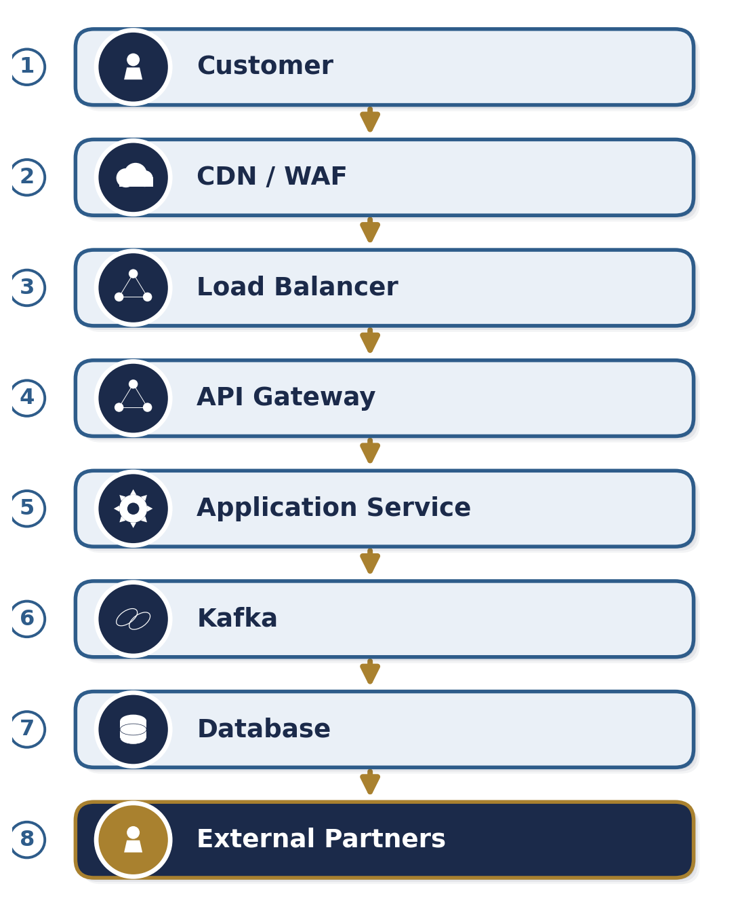
Validation Checklist
Validation Area | Detail | Status
Transaction Flow | Complete transaction flow available | ☐
Sequence Diagram | Reviewed | ☐
Authentication | Validated across hops | ☐
Encryption | Validated across hops | ☐
Failure Scenarios | Reviewed | ☐
Retry Strategy | Reviewed | ☐
Circuit Breakers | Reviewed | ☐
Performance Benchmark | Available | ☐
Capacity Sizing | Completed | ☐
Monitoring Points | Identified | ☐
DR Scenarios | Reviewed | ☐
Data Lineage | Documented | ☐
Audit Trail | Available | ☐
Support Ownership | Identified | ☐

10 Terraform Readiness Sign-Off — Mandatory Gate
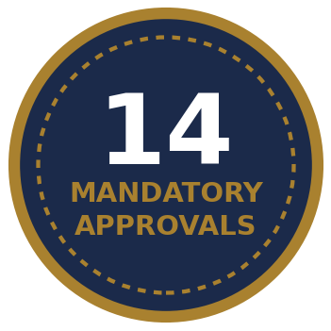
  No Terraform development should begin until all items below are approved.

Area | Approval Required
HLD Approved | ✓ Yes
LLD Approved | ✓ Yes
Network Design Approved | ✓ Yes
Security Review Approved | ✓ Yes
Threat Model Approved | ✓ Yes
Operational Runbook Approved | ✓ Yes
Capacity Planning Approved | ✓ Yes
Observability Design Approved | ✓ Yes
Integration Design Approved | ✓ Yes
ARB Approval Obtained | ✓ Yes
DR Strategy Approved | ✓ Yes
IAM Model Approved | ✓ Yes
Naming Standards Approved | ✓ Yes
Tagging Standards Approved | ✓ Yes

APPROVALS

Final Signatories
Role | Sign-off
Application Architect
Platform Architect
Security Architect
Network Architect
Database Architect
SRE Lead
Operations Lead
Delivery Lead
Architecture Review Board

GOLDEN RULE FOR PLATFORM ENGINEERING
“No Terraform without Approved Architecture, No Deployment without Approved Operations, No Production without Approved Observability.”

